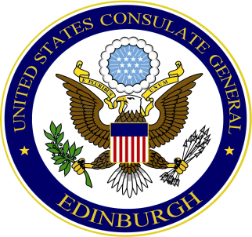

U.S. Consulate General Edinburgh
Management & Consular Affairs Consul
Vicki Ting
and
The American Women’s Club of Central Scotland
Cordially invite you to attend the
AWCCS 2023 Annual General Meeting
Tuesday May 16, 2023
6:00 – 8:00 p.m.
U.S. Consulate General, 3 Regent Terrace, Edinburgh, EH7 5BW

RSVP through the AWCCS club website by Friday May 13

