Join the American Women’s Club of Central Scotland
for a Chocolate Tour at
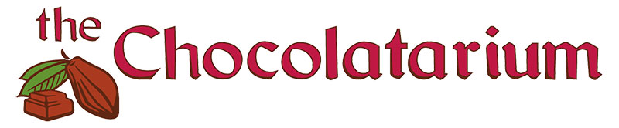 Outing: The Chocolatarium Chocolate Tour
Date: Saturday, 29th April
Venue: 3-5 Cranston Street, Edinburgh EH8 8BE
Time: 12.30pm - 2:00pm
Cost: £22 - must be paid by Friday, 21st April
Tickets Available: 12
The original 90-minute, fully-guided Tour of Chocolate
- create your very own dream chocolate bar to take away
- discover the magic of where chocolate comes from
- see and smell how chocolate is made
- choose from over 40 flavors in the Tasting Room
There are a few steps and a narrow door if you have mobility issues.

RSVP using this website before Friday, 21st April

£22 Advanced Payment Required via Bank Transfer to:
American Women’s Club of Central Scotland (a business account)
Bank of Scotland
Sort code 80-02-78
Account No. 00952279
Reference your surname and “CHOC”

Any questions – contact Sallie Redman at maltatransplant@gmail.com

